**Static Design for Traffic Light**

**Microcontroller**

**DIO**

**Led**

**APP**

**APP**

**ECUAL**

**MCAL**

Services

**SER_UART**

**UART**

**MCAL APIs**

* **DIO APIs**

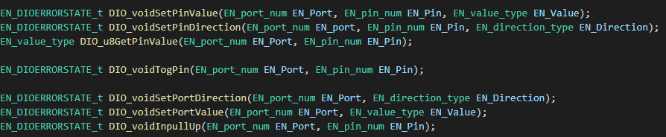

* **UART APIs**

EN_ERRORSTATE_t UART_ENInit(void);

EN_ERRORSTATE_t UART_ENSendData(uint8_t Data);

EN_ERRORSTATE_t UART_ENSendNoBlock(uint8_t Data);

uint8_t UART_u8ReceiveData(void);

uint8_t UART_u8Receive NoBlock(uint8_t *Data);

**ECUAL APIs**

* **Led APIs**

Void LED_voidInit(void);

Void LED_voidOn(uint8_t Led_Num);

Void LED_voidOff(uint8_t Led_num);

Void LED_voidToggle(uint8_t Led_num);

**Services APIs**

* **SER_UART APIs**

Void SER_UARTvoidSendString(uint8_t *Str);

Void SER_UARTvoidReceiveString(uint8_t *Str);

Void SER_UARTvoidReceiveStringNoBLOCKING(uint8_t *Str);

Void SER_UARTvoidSendLongNum(uint32_t Numb);

Void SER_UARTvoidReceiveLongNum(void);

**APP APIs**